Discover Thailand with INTRO TRAVELS INDIA
Thailand, known as the “Land of Smiles,” is one of Asia’s most popular travel destinations, famous for tropical islands, vibrant nightlife, beautiful temples, luxury resorts, delicious street food, and exciting adventures. From the bustling streets of Bangkok to the crystal-clear beaches of Phuket and Krabi, Thailand offers the perfect mix of culture, relaxation, entertainment, and adventure.
Whether you are planning a honeymoon, family holiday, solo trip, or group getaway, Thailand promises an unforgettable international travel experience.

Why Visit Thailand?
- Stunning tropical beaches & islands
- Affordable luxury holidays
- Vibrant nightlife & entertainment
- Beautiful Buddhist temples
- Delicious Thai cuisine
- Adventure & water sports
- Luxury shopping & floating markets
- Friendly locals & rich culture

Top Tourist Attractions in Thailand
1. Bangkok – The Vibrant Capital
Bangkok is famous for its nightlife, shopping, temples, and modern city life.
Top attractions:
- Grand Palace
- Wat Arun
- Floating Markets
- Chao Phraya River Cruise
- Luxury malls & street markets
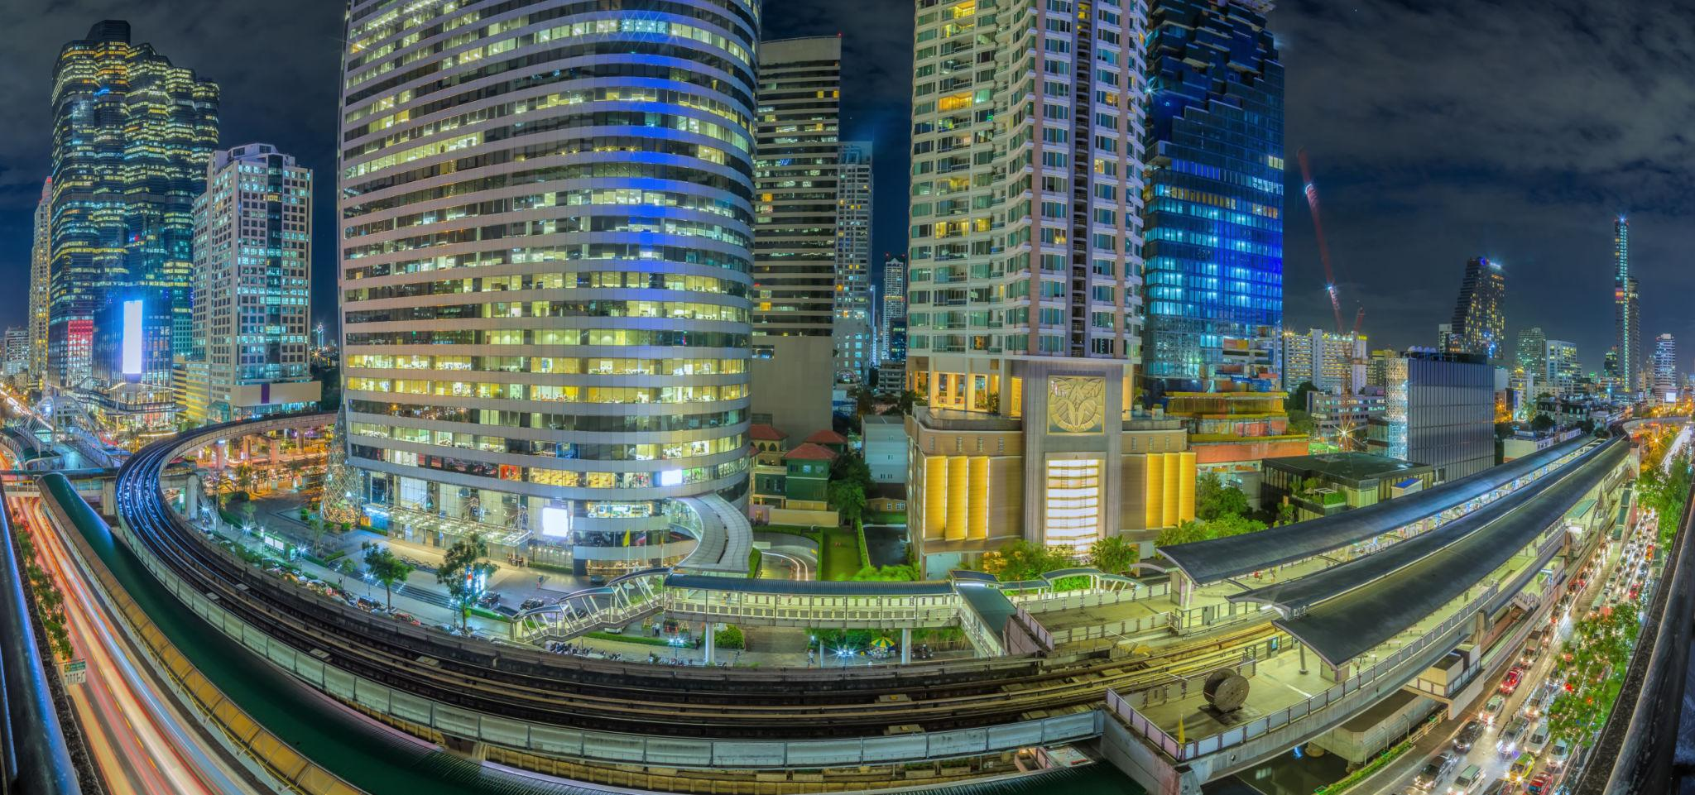
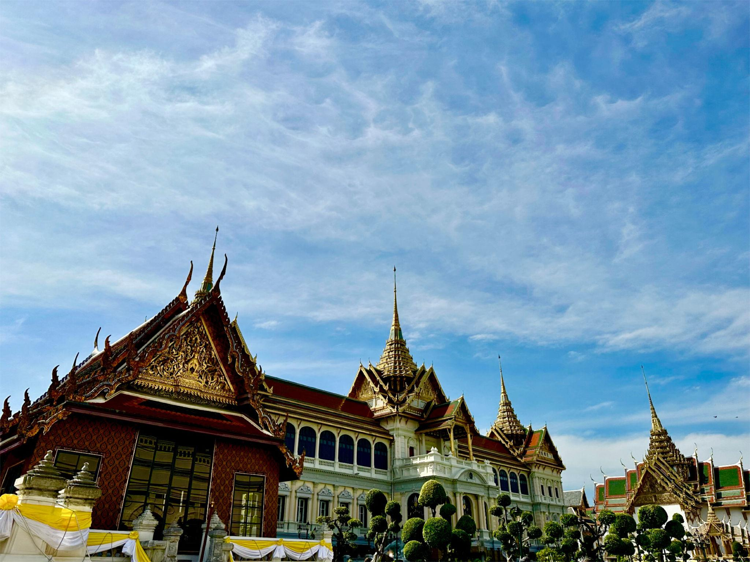
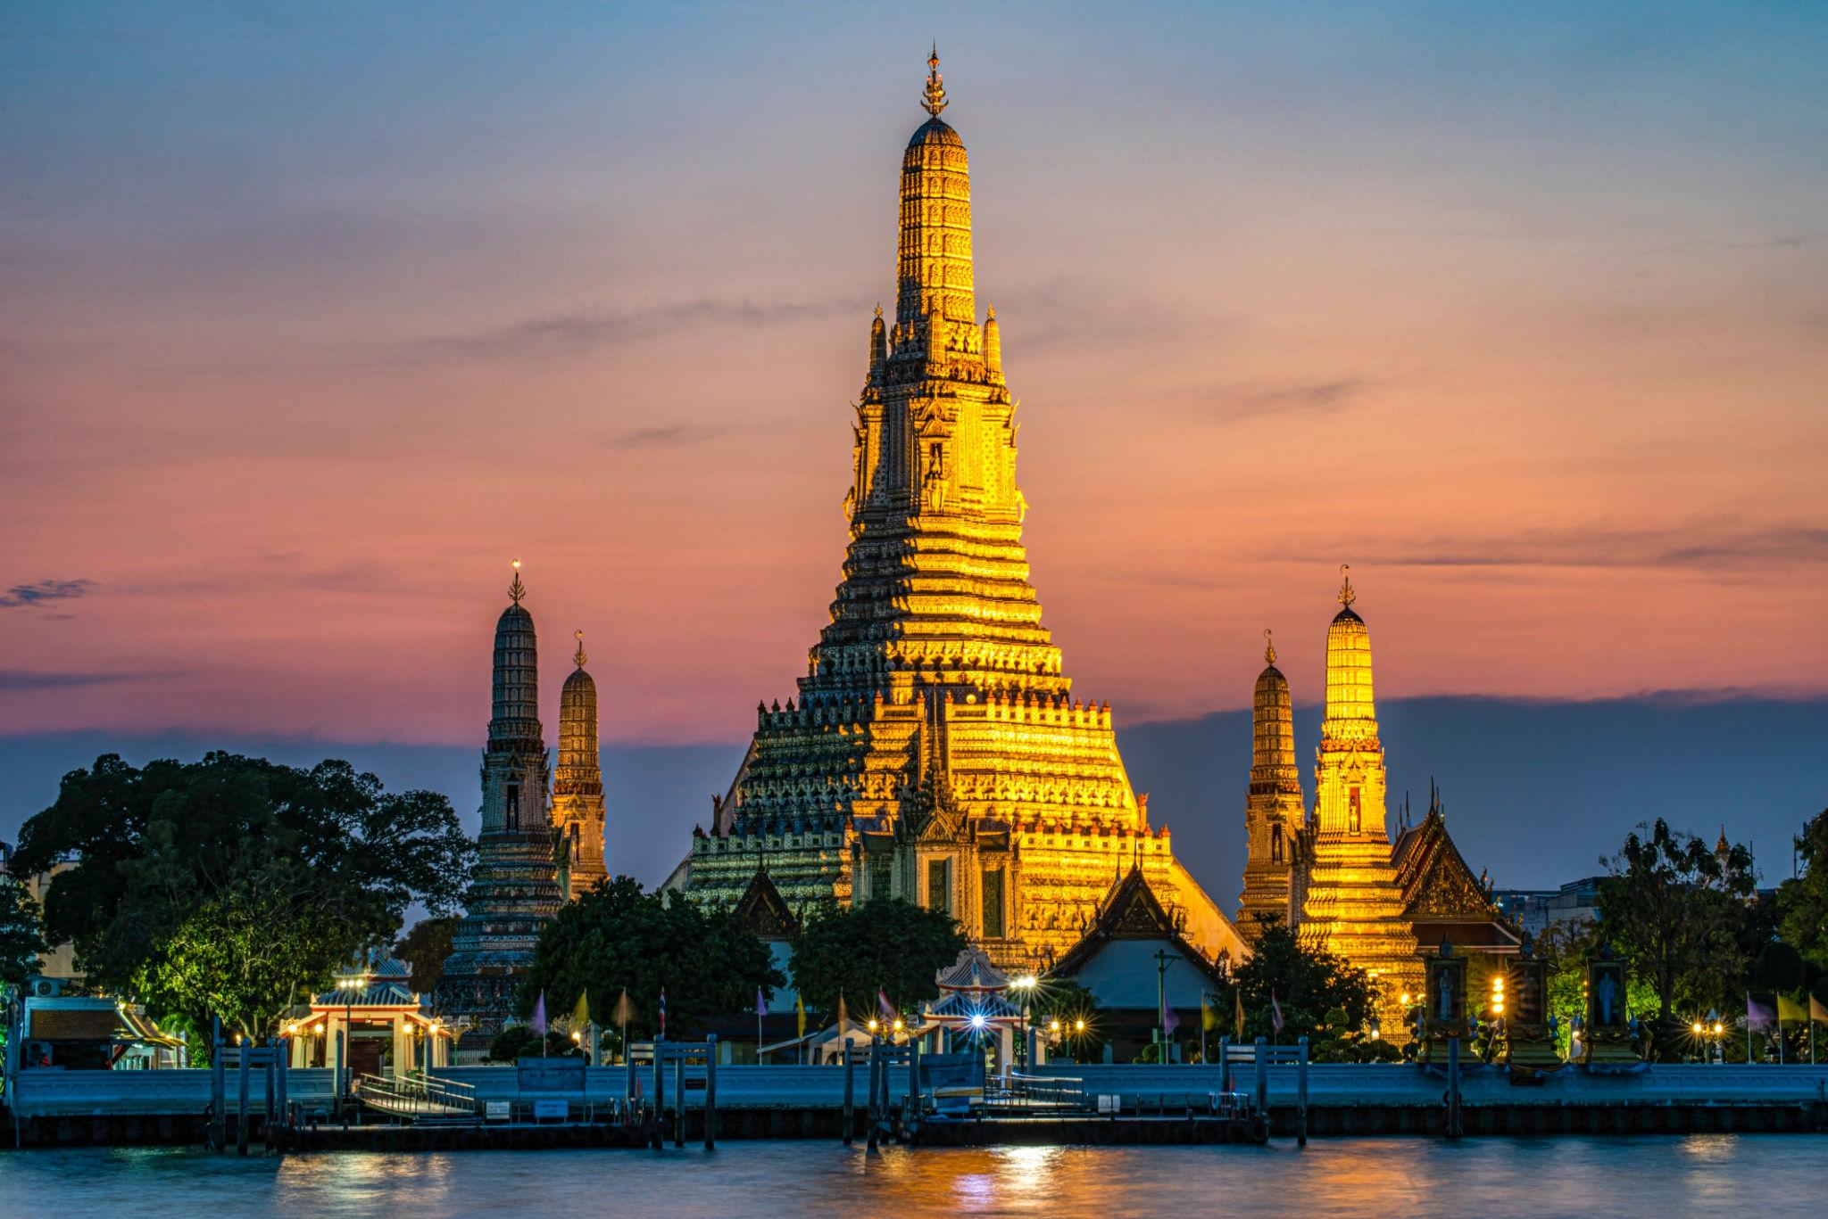
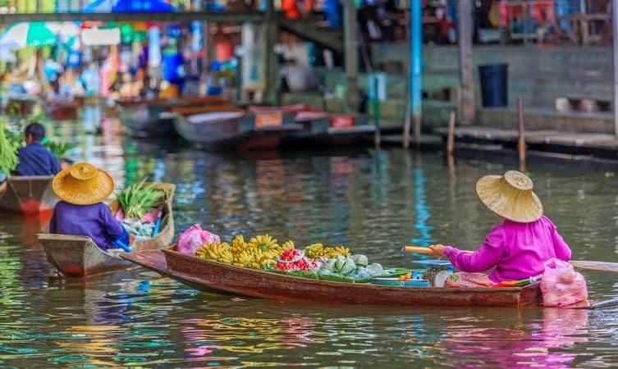
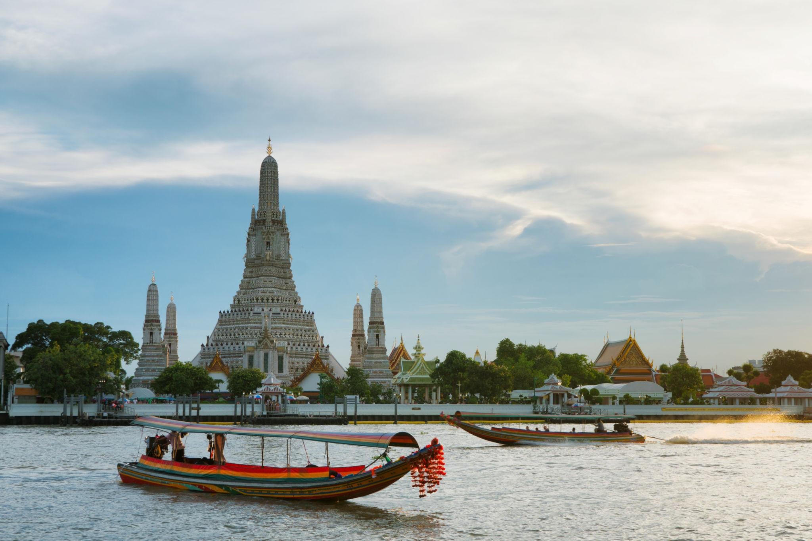

2. Phuket – Thailand’s Beach Paradise
Thailand’s largest island is famous for beaches, nightlife, and water sports.
Best experiences:
- Patong Beach
- Phi Phi Island tours
- Sunset cruises
- Snorkeling & scuba diving
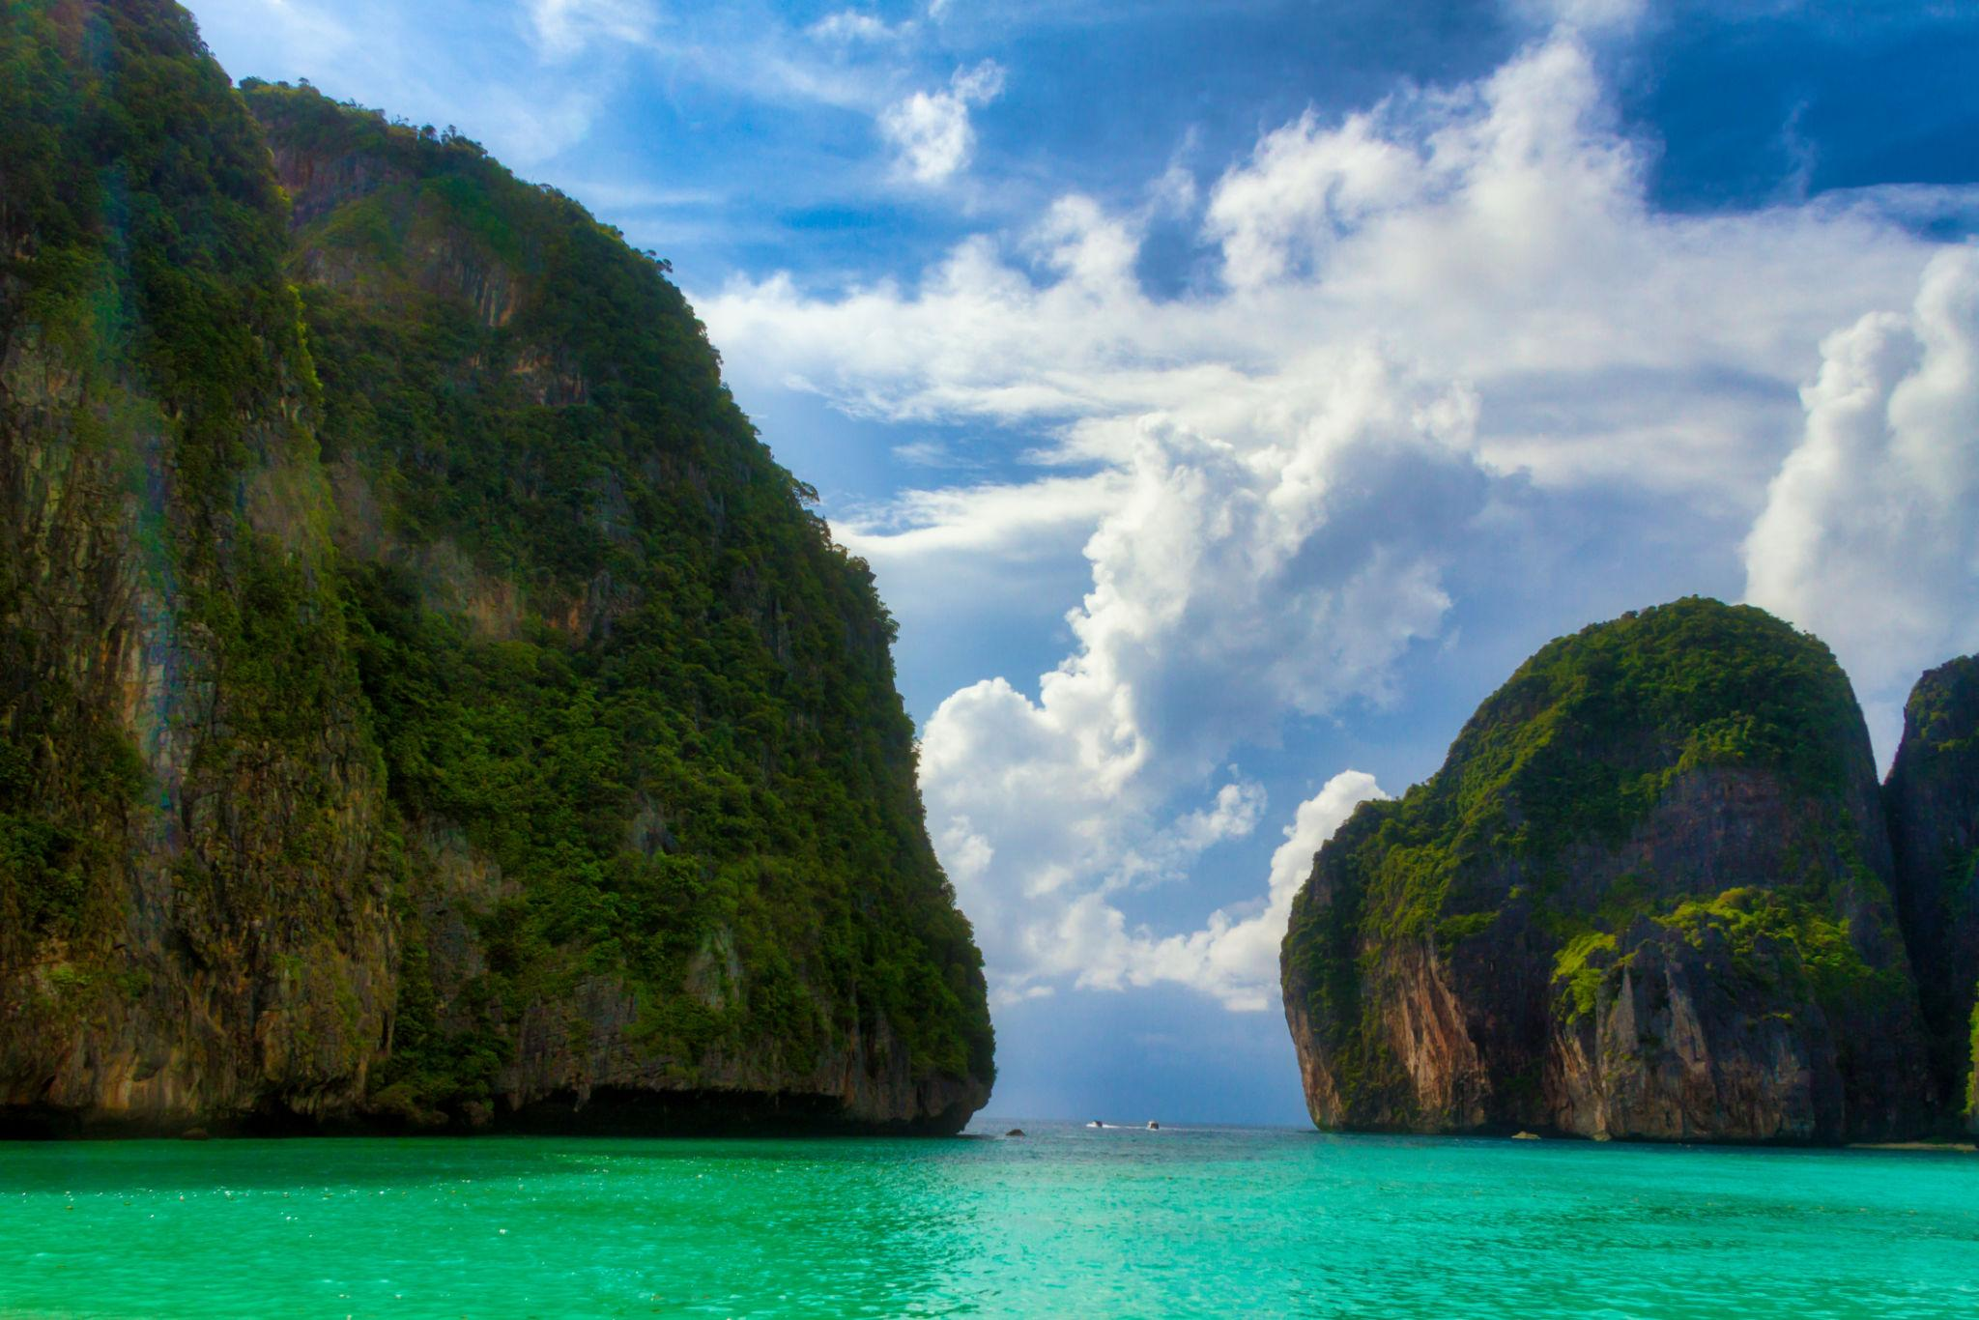
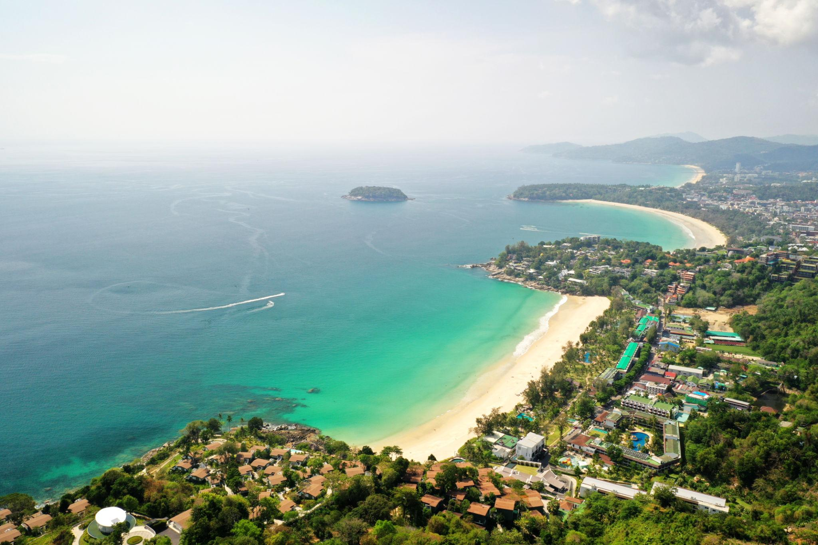
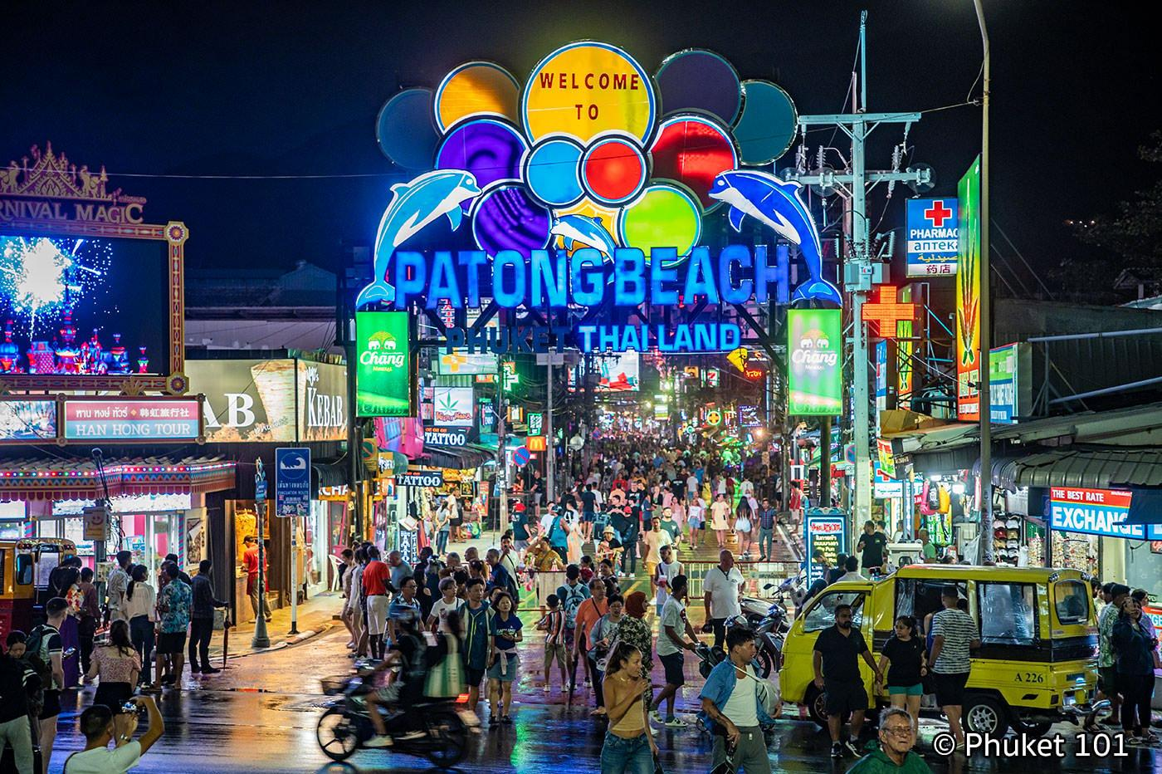
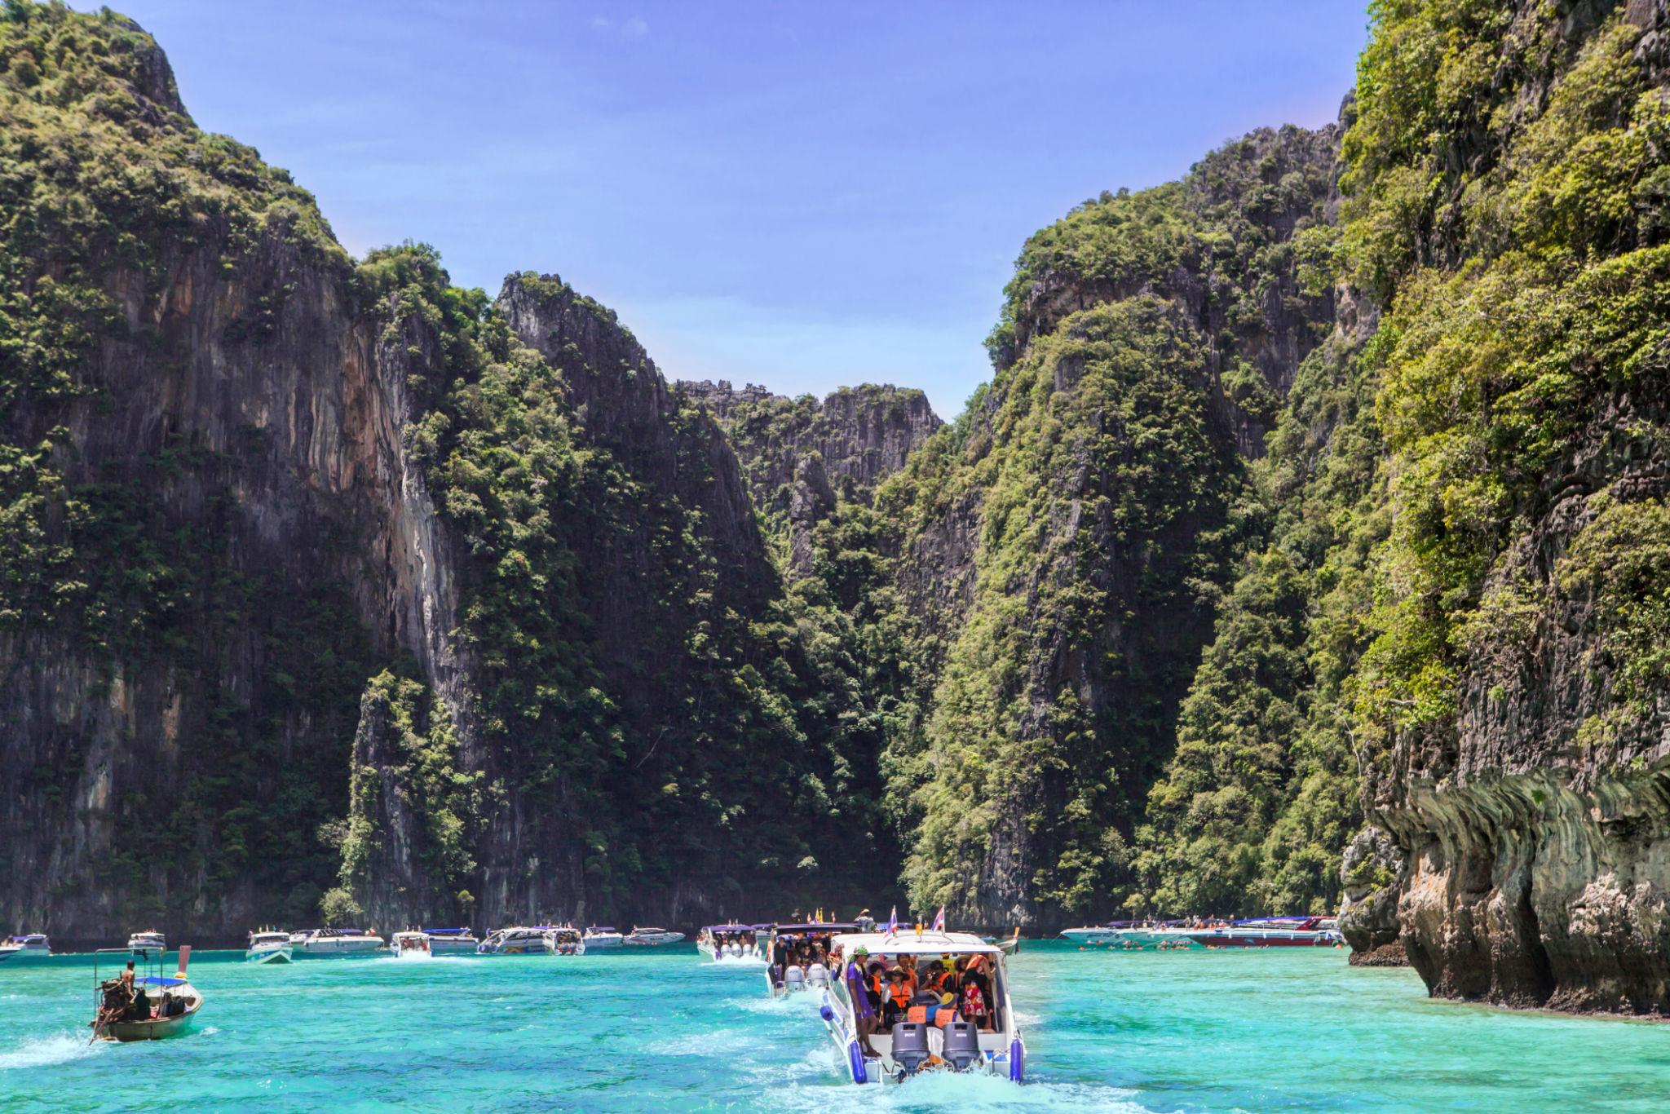
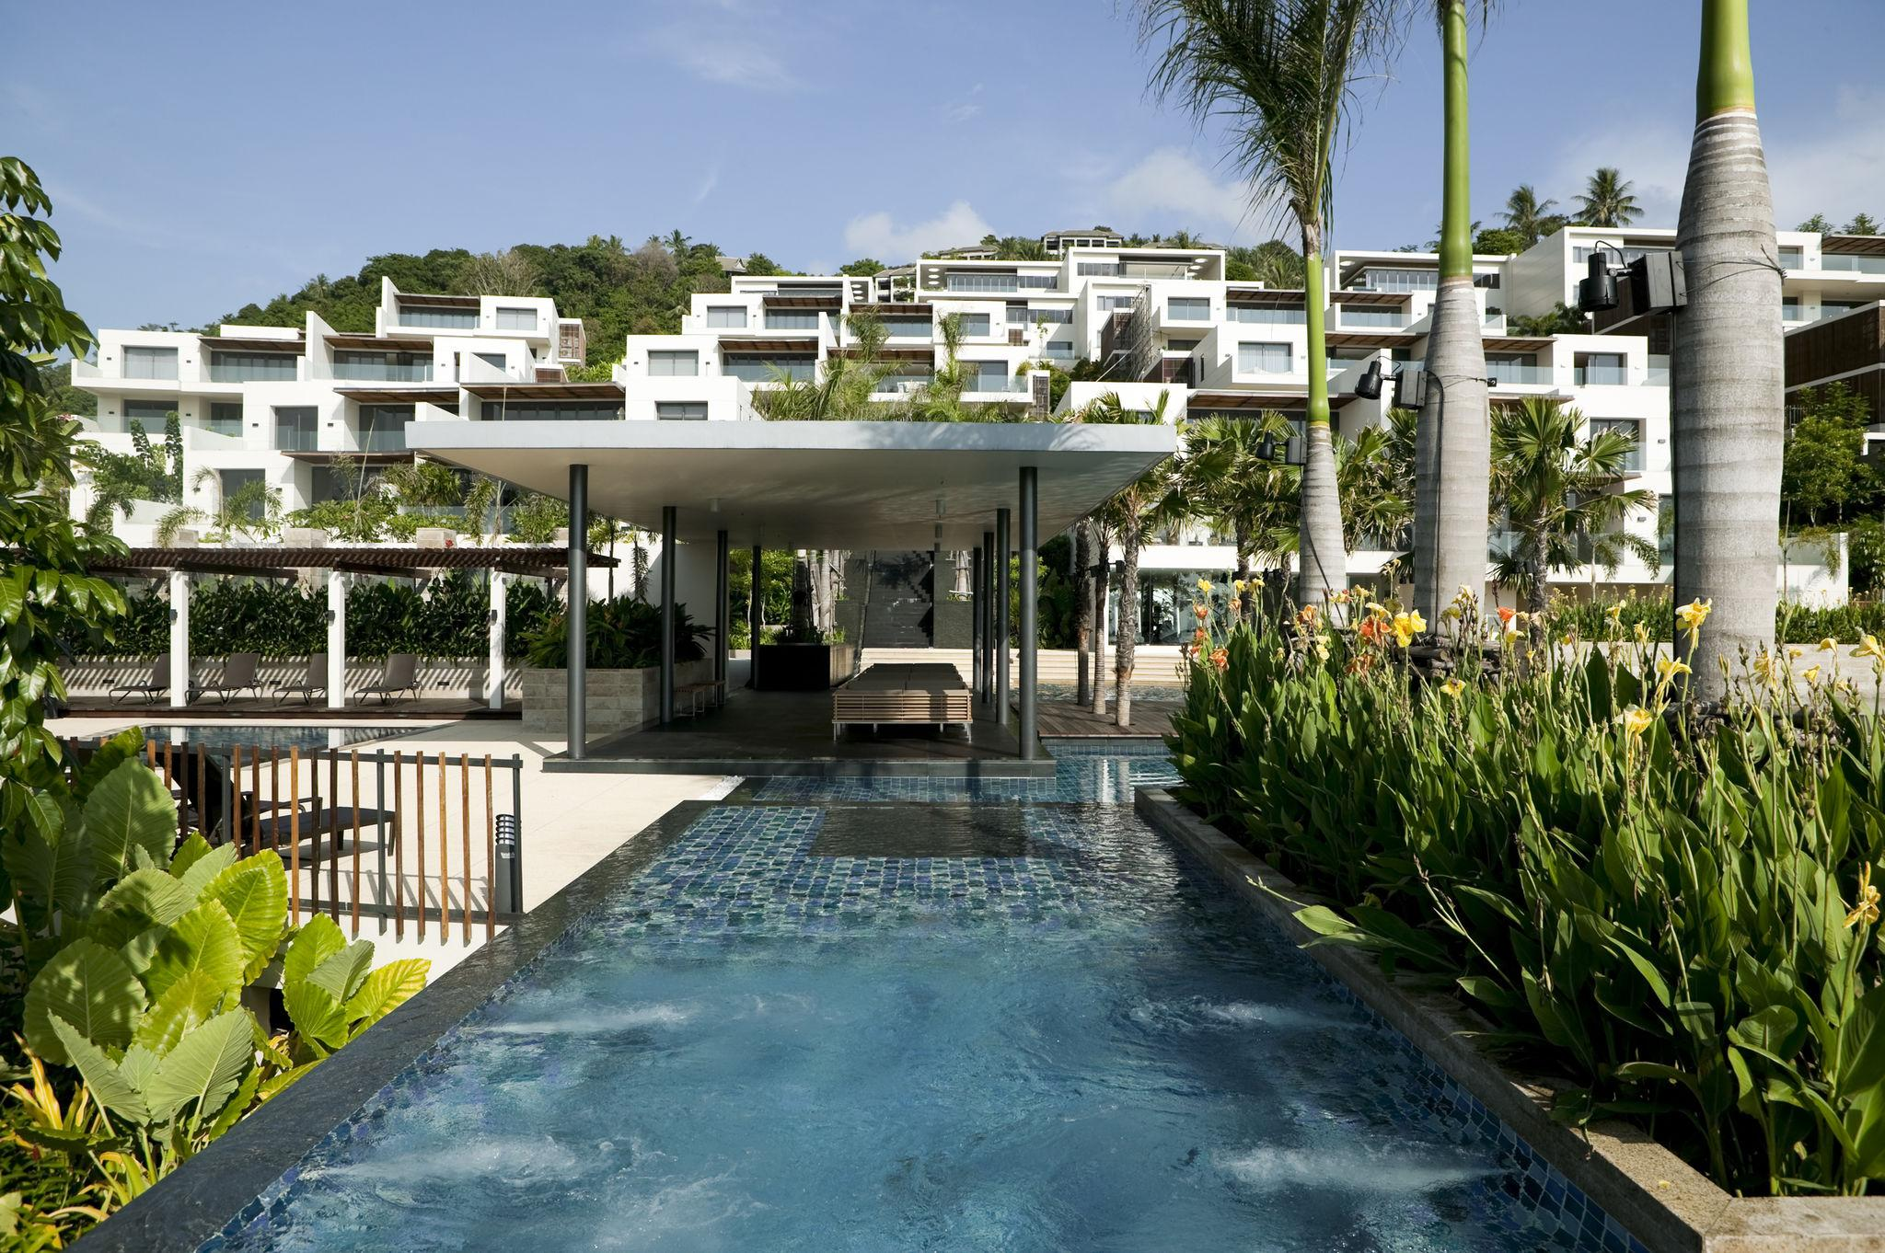

3. Krabi
Known for dramatic limestone cliffs and turquoise waters.
Must visit:
- Railay Beach
- Four Islands Tour
- Emerald Pool
- Island hopping

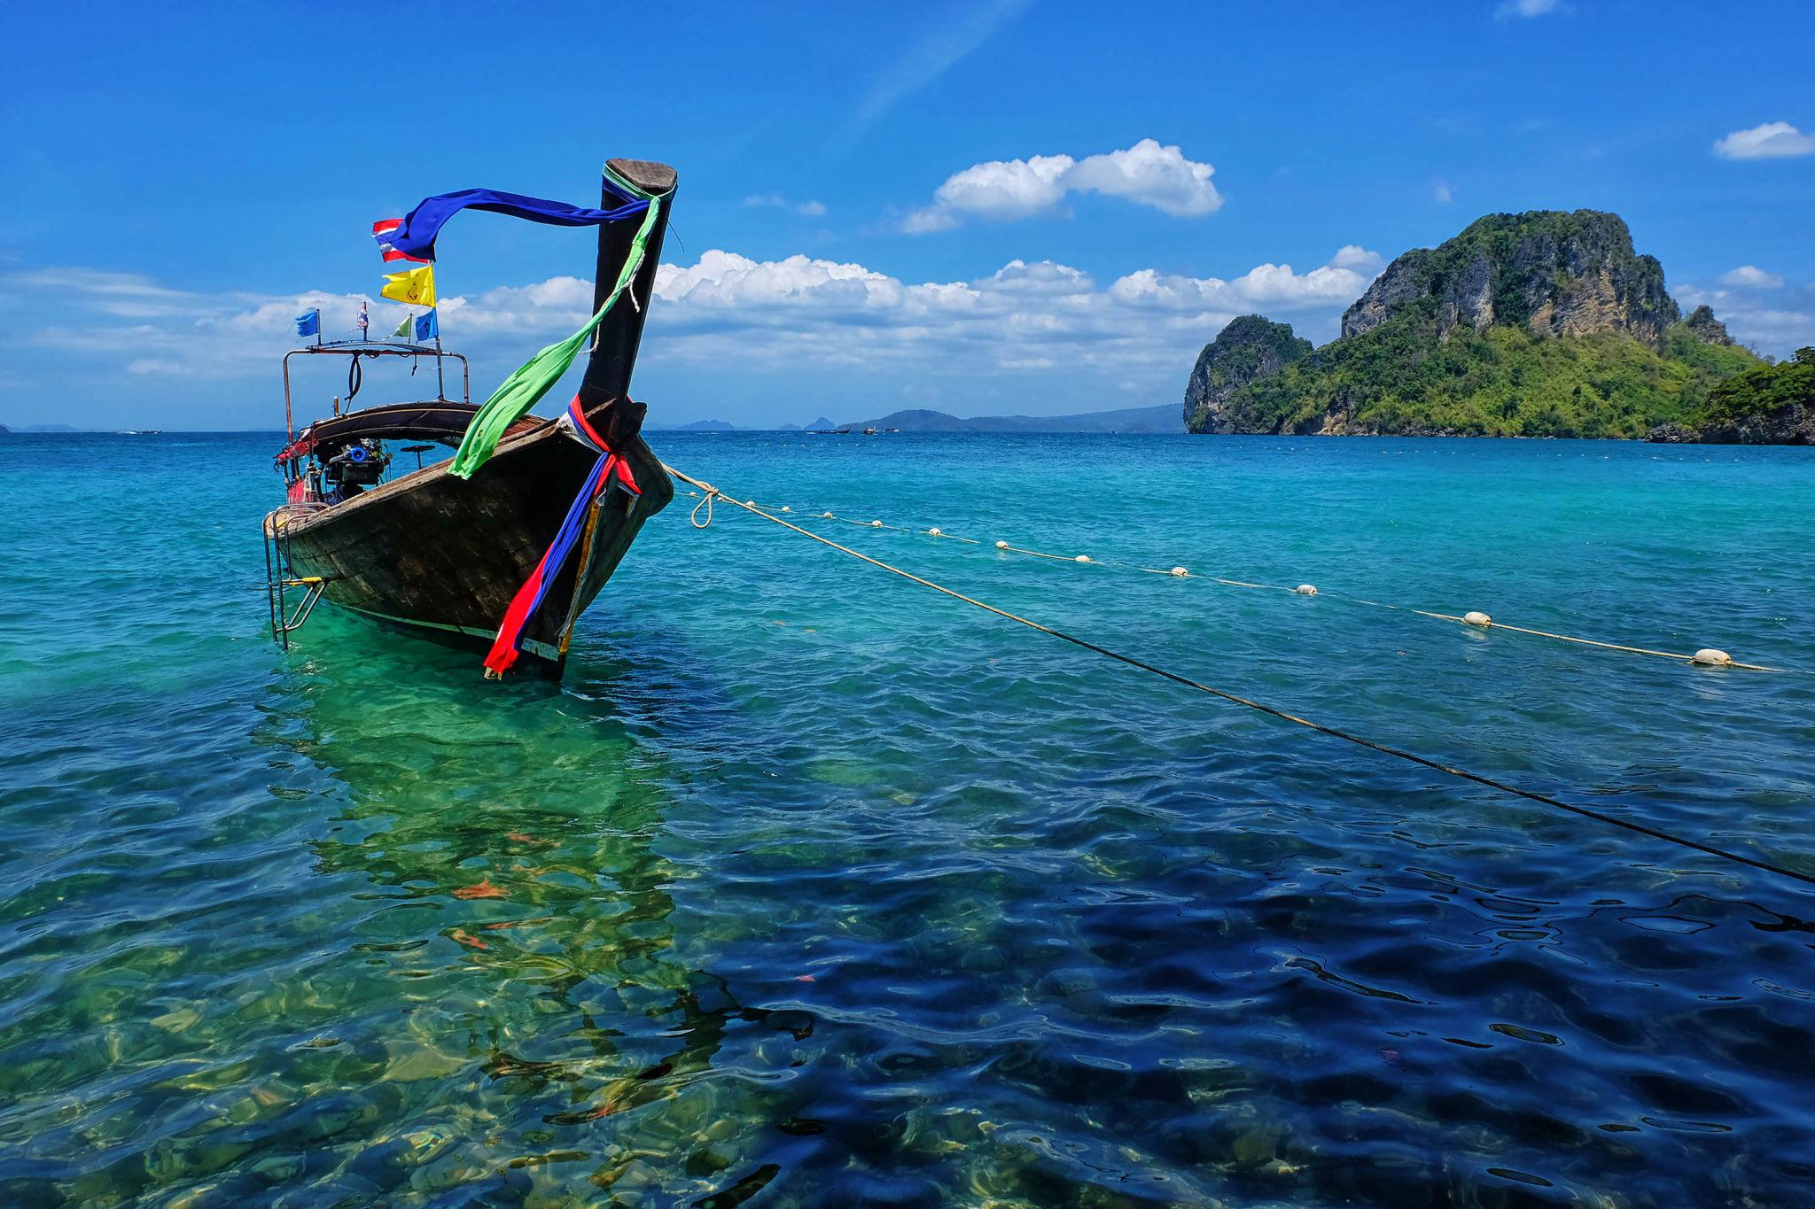




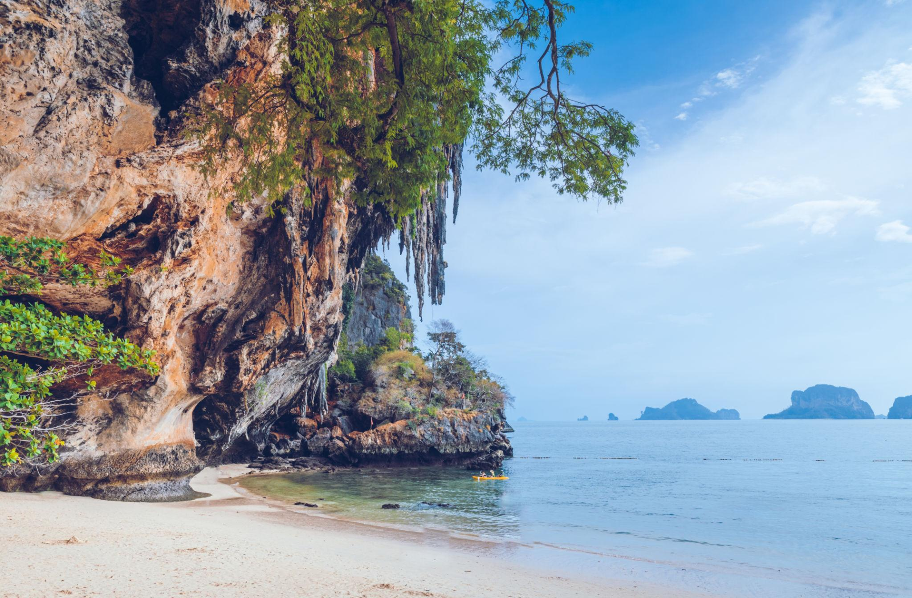


4. Pattaya
A popular beach destination known for entertainment and nightlife.
Highlights:
- Walking Street
- Coral Island Tour
- Water sports
- Cabaret shows
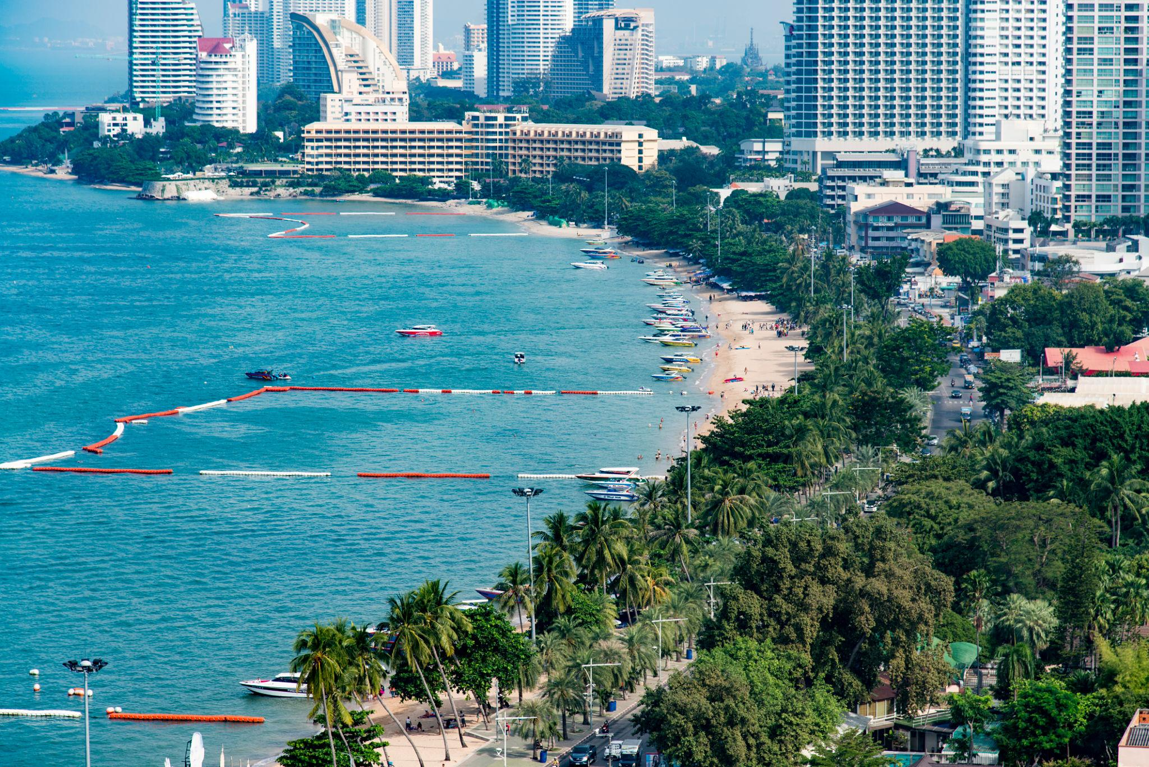
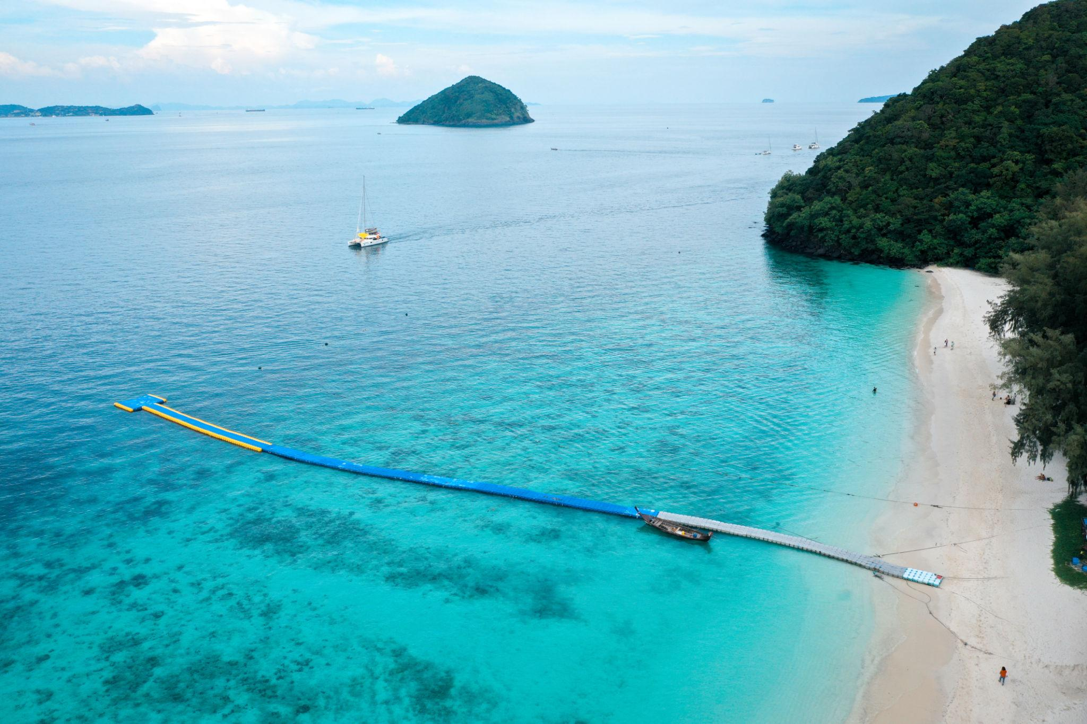
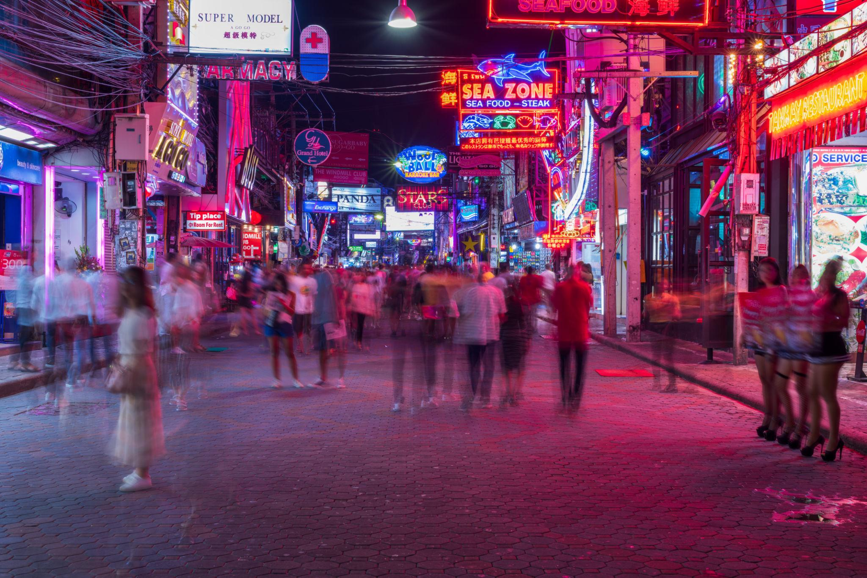
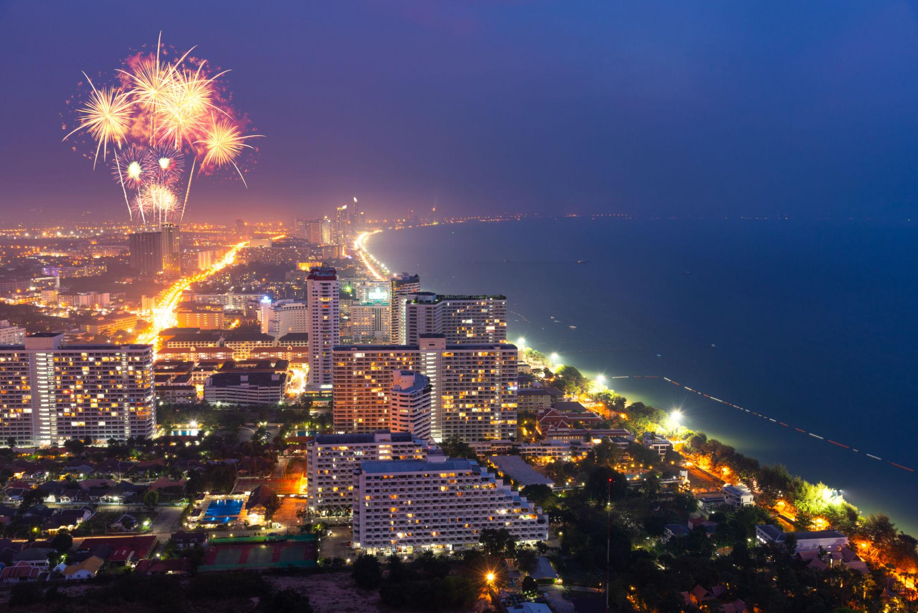
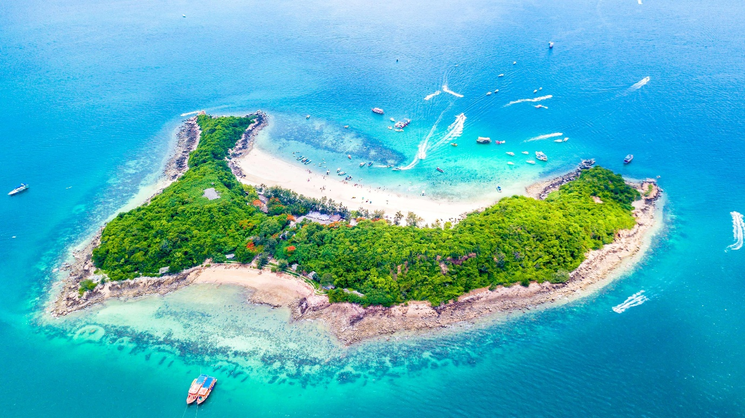
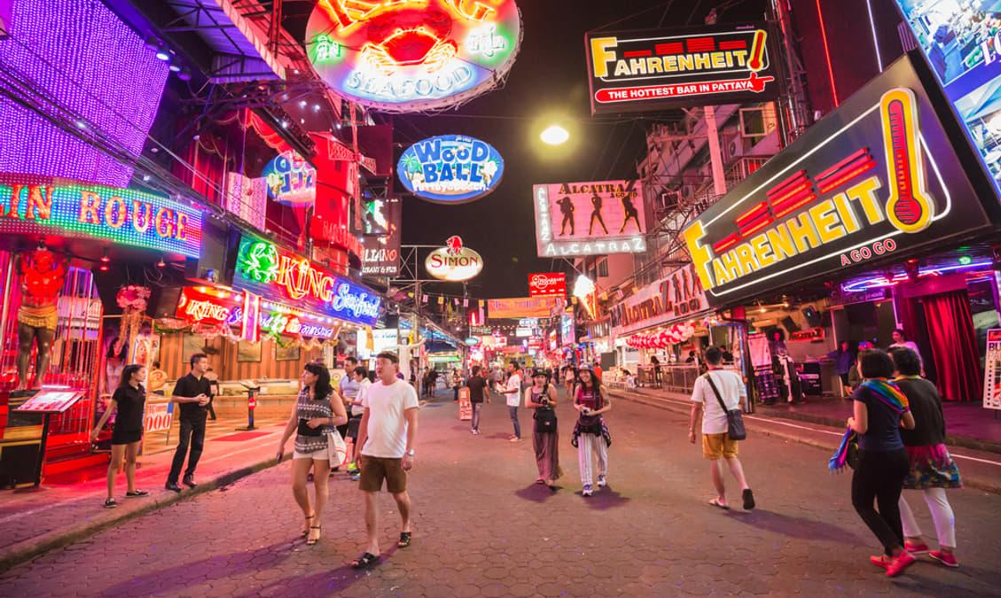

5. Chiang Mai
Thailand’s cultural and mountain destination.
Famous for:
- Ancient temples
- Night markets
- Elephant sanctuaries
- Mountain landscapes
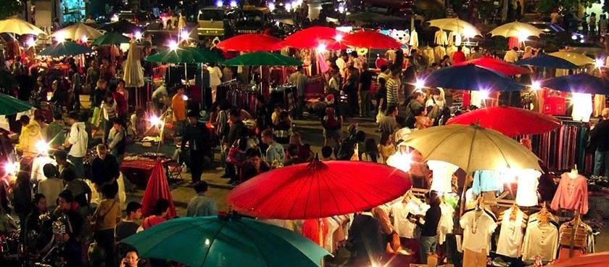
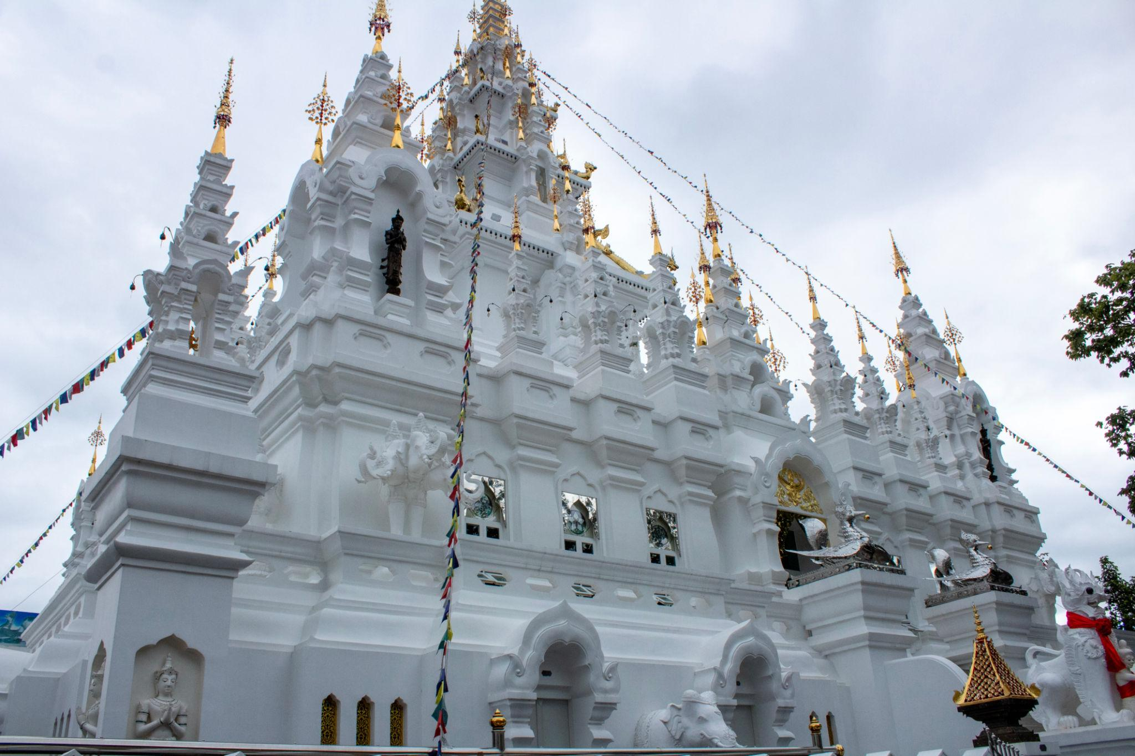
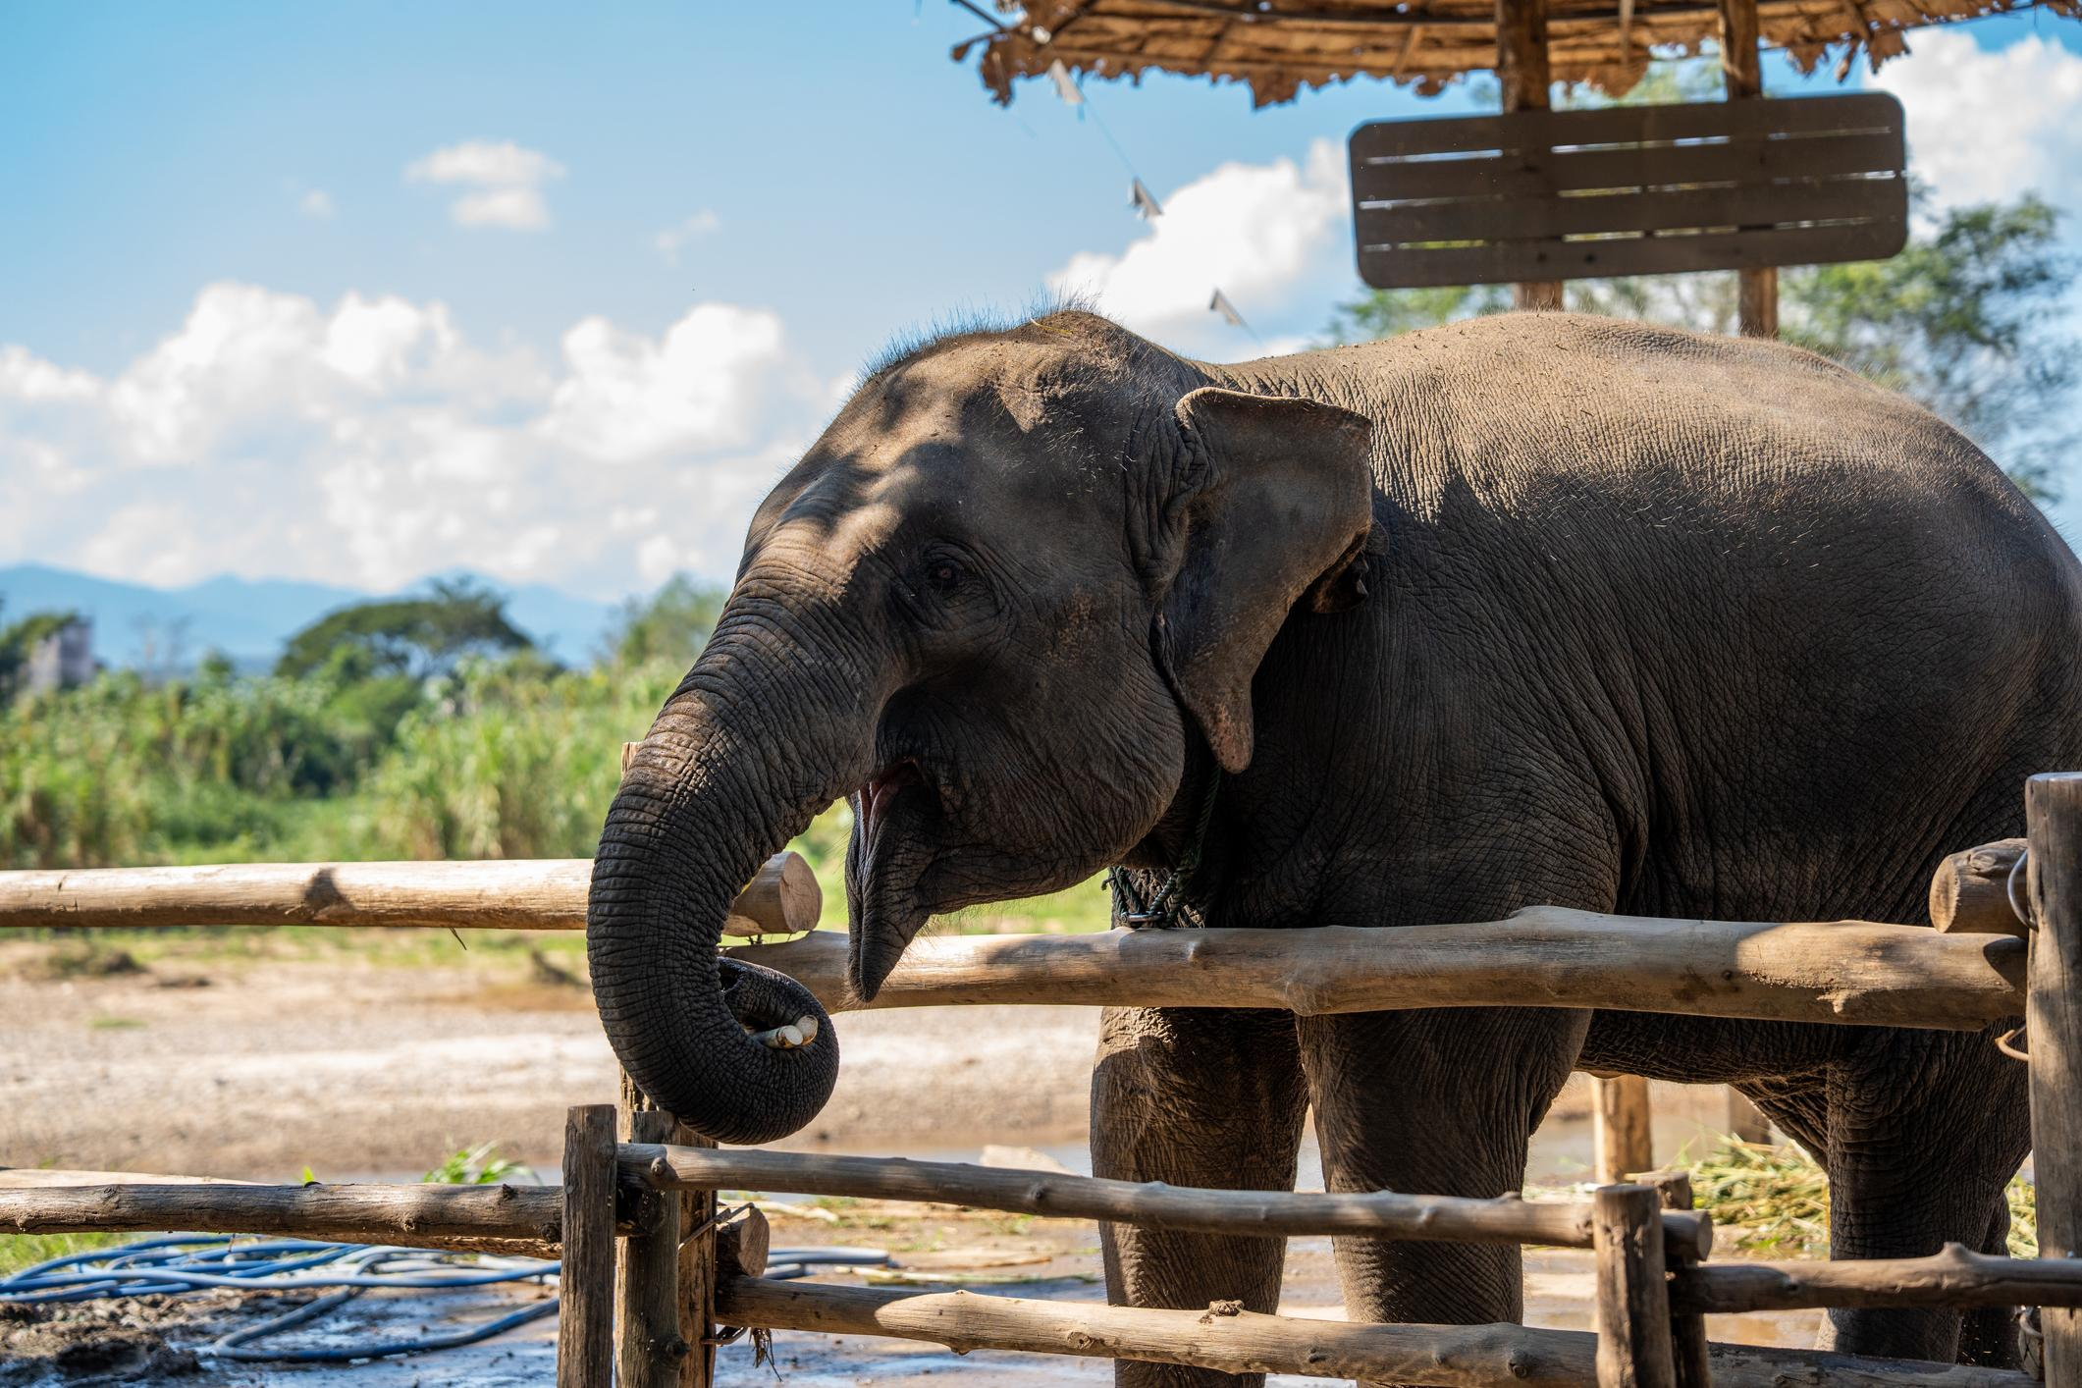

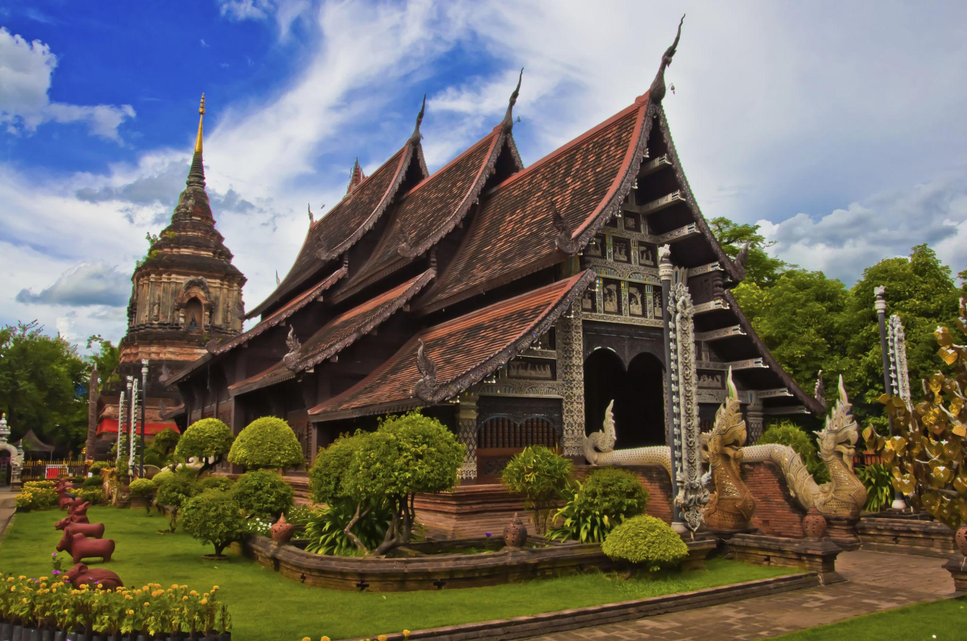
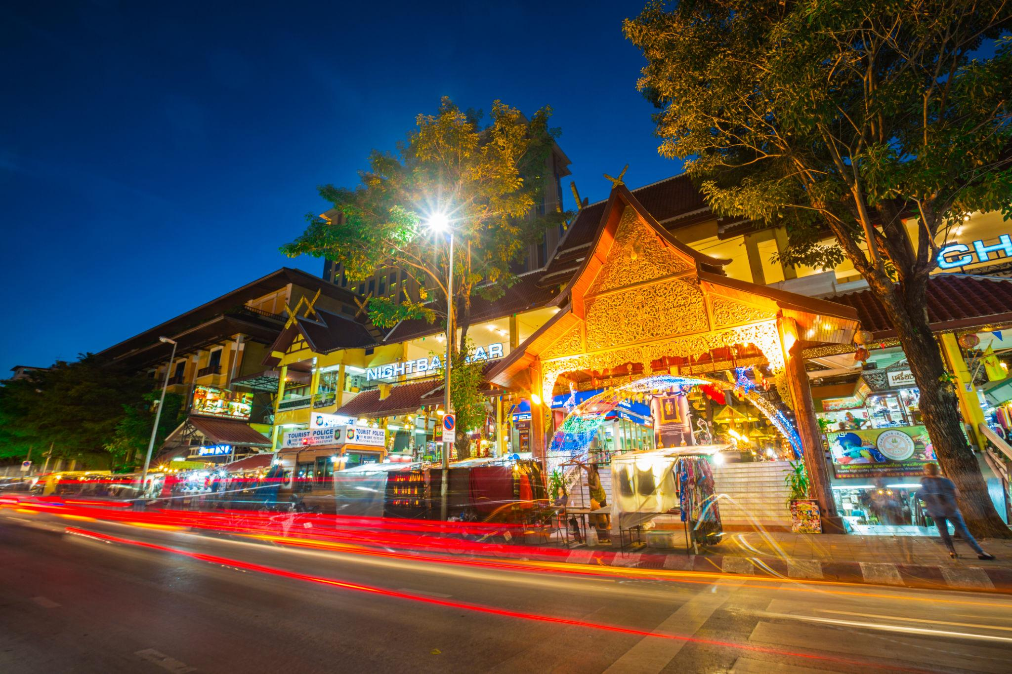

Best Things to Do in Thailand
- Visit Buddhist temples
- Explore floating markets
- Enjoy island hopping tours
- Relax on tropical beaches
- Experience Thai nightlife
- Go scuba diving & snorkeling
- Enjoy Thai massage & spa
- Attend Full Moon Parties
- Shop at local markets
- Try authentic Thai street food

Best Time to Visit Thailand
Region | Best Time
Bangkok & Central Thailand | November – February
Phuket & Krabi | November – April
Chiang Mai | November – February
The coolest and most pleasant season is from November to February.

Thailand Visa for Indians 🇮🇳
Indian travelers may enjoy:
- Visa-or visa-on-arrival (subject to current regulations)
- Passport valid for 6 months
- Return flight tickets
- Hotel bookings
- Sufficient funds proof
Travel rules may change, so always check the latest Thailand immigration updates before travel.

Famous Thai Foods to Try 🍜
- Pad Thai
- Tom Yum Soup
- Green Curry
- Mango Sticky Rice
- Thai Fried Rice
- Thai Seafood
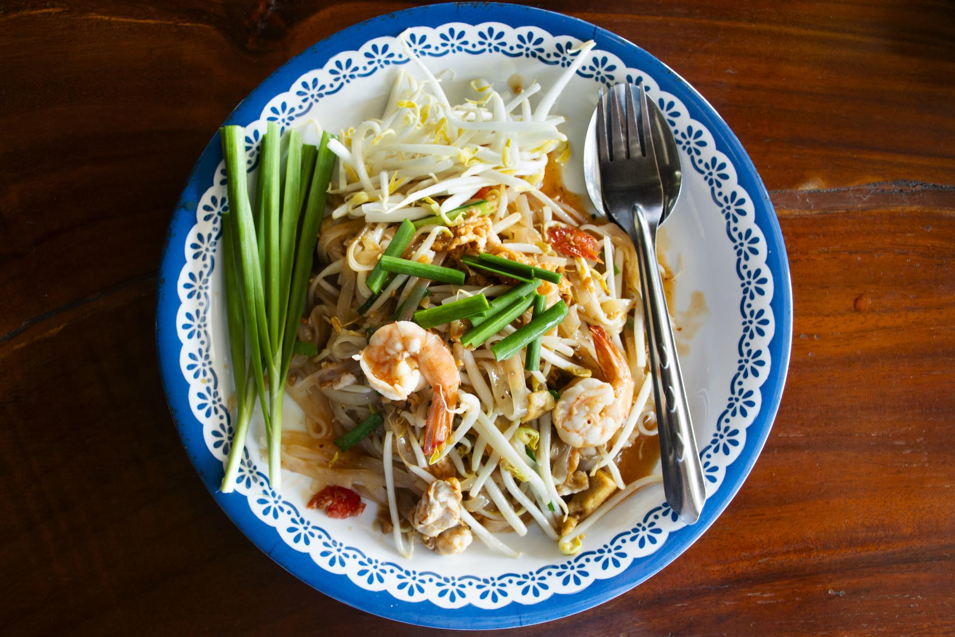
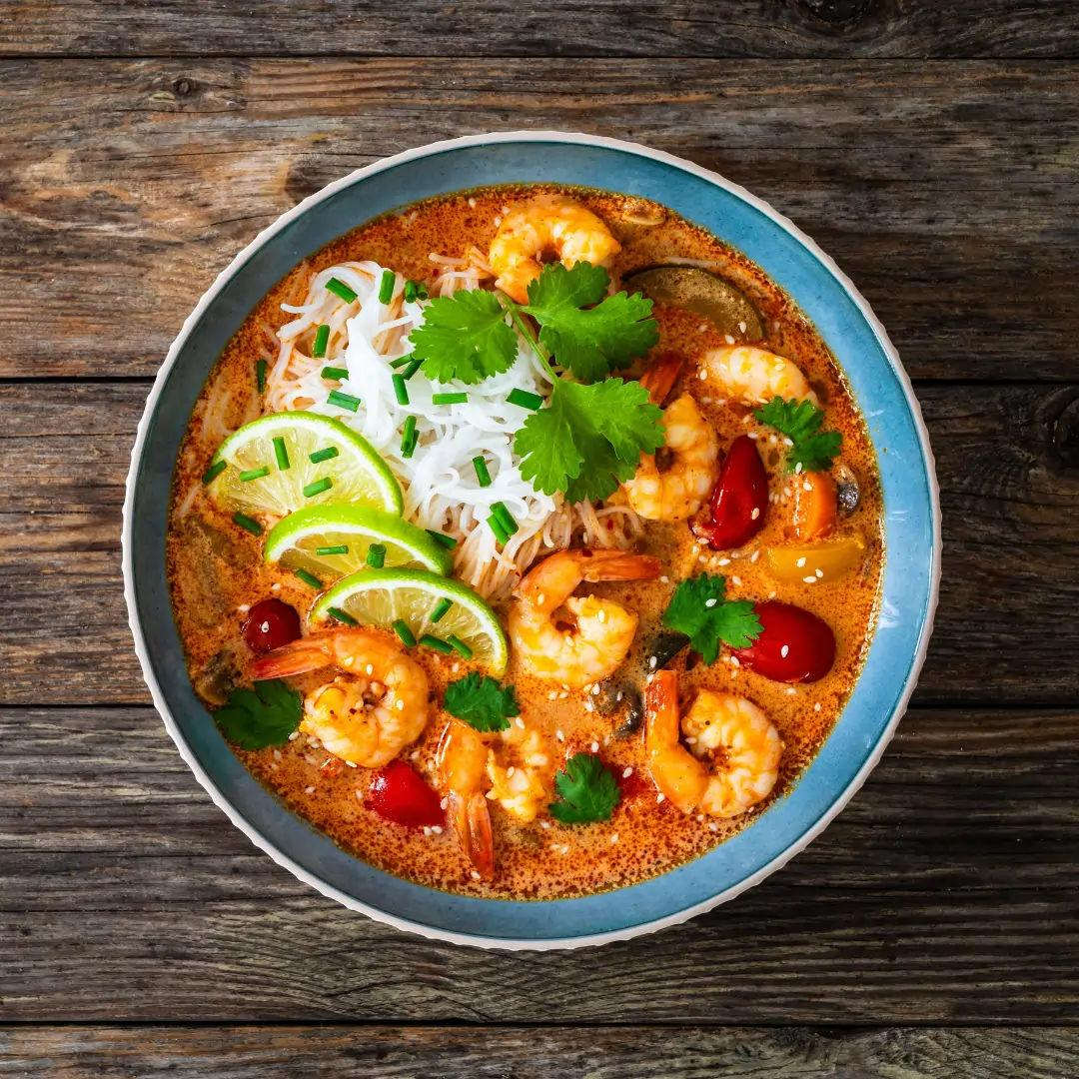
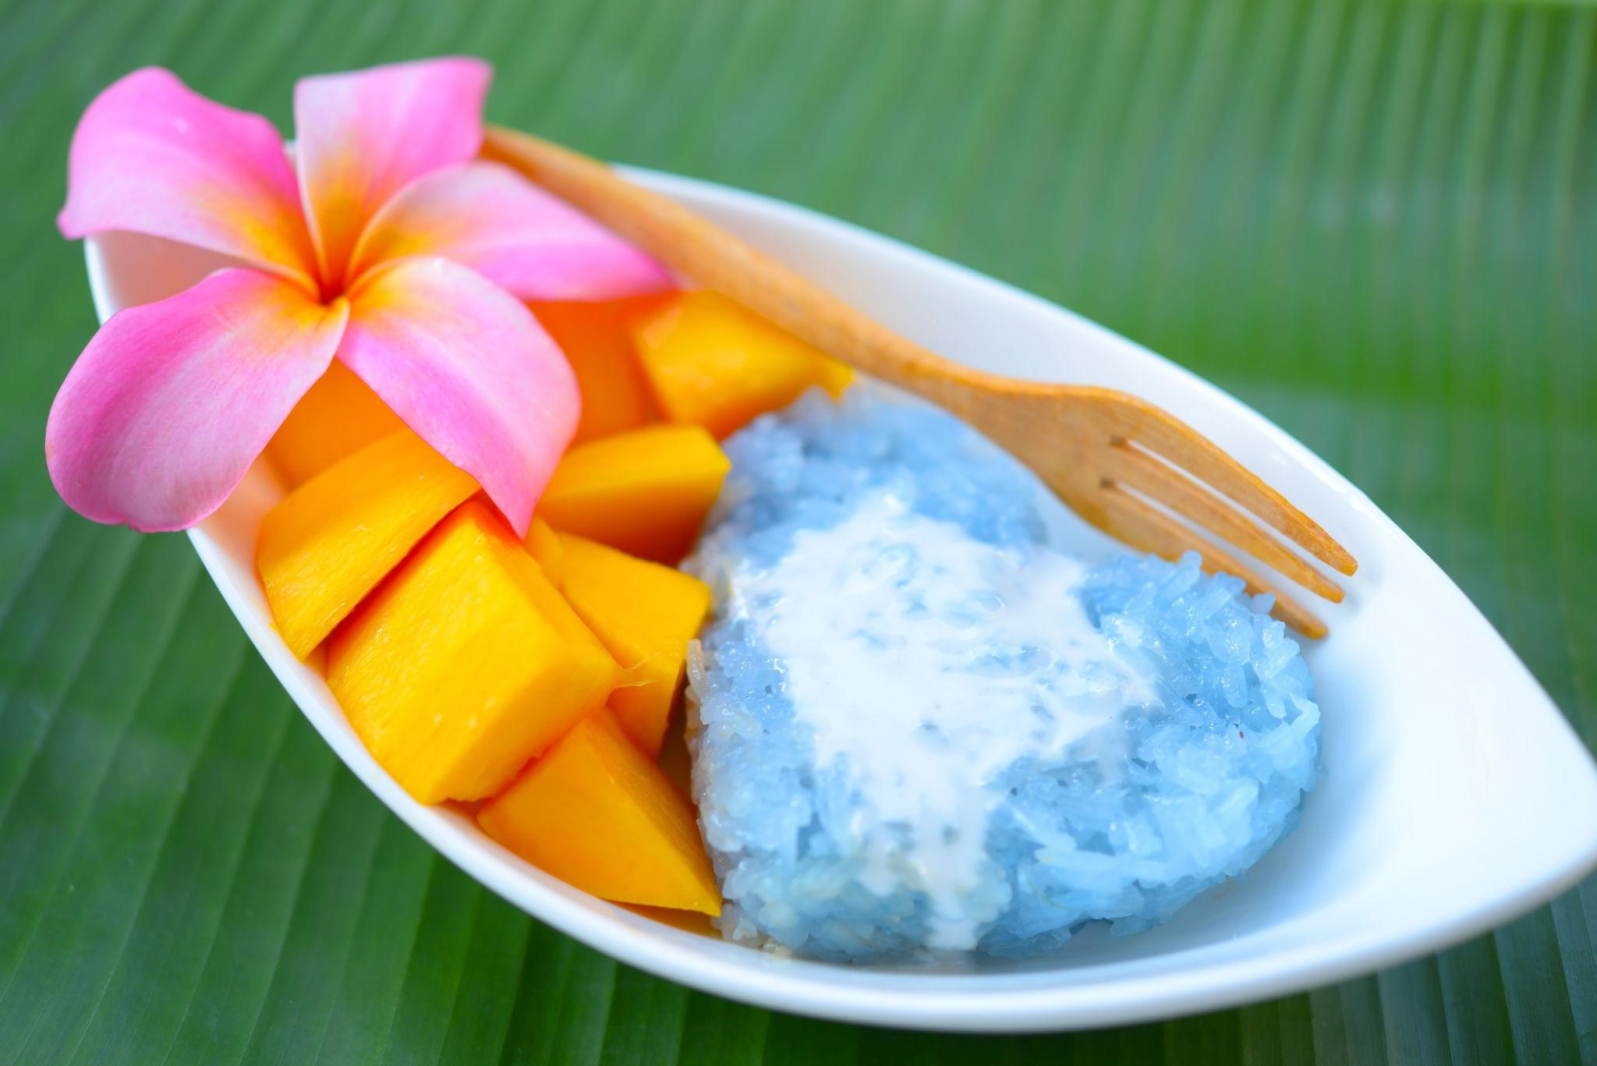
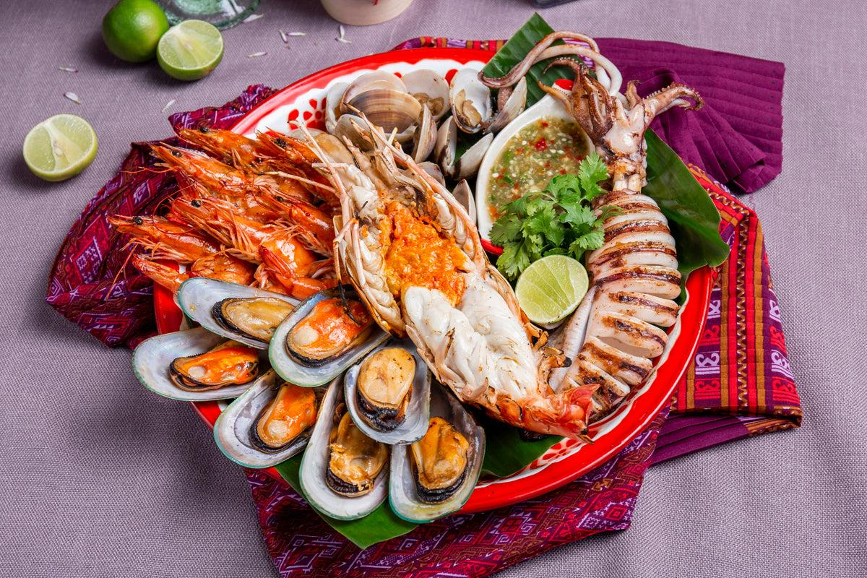
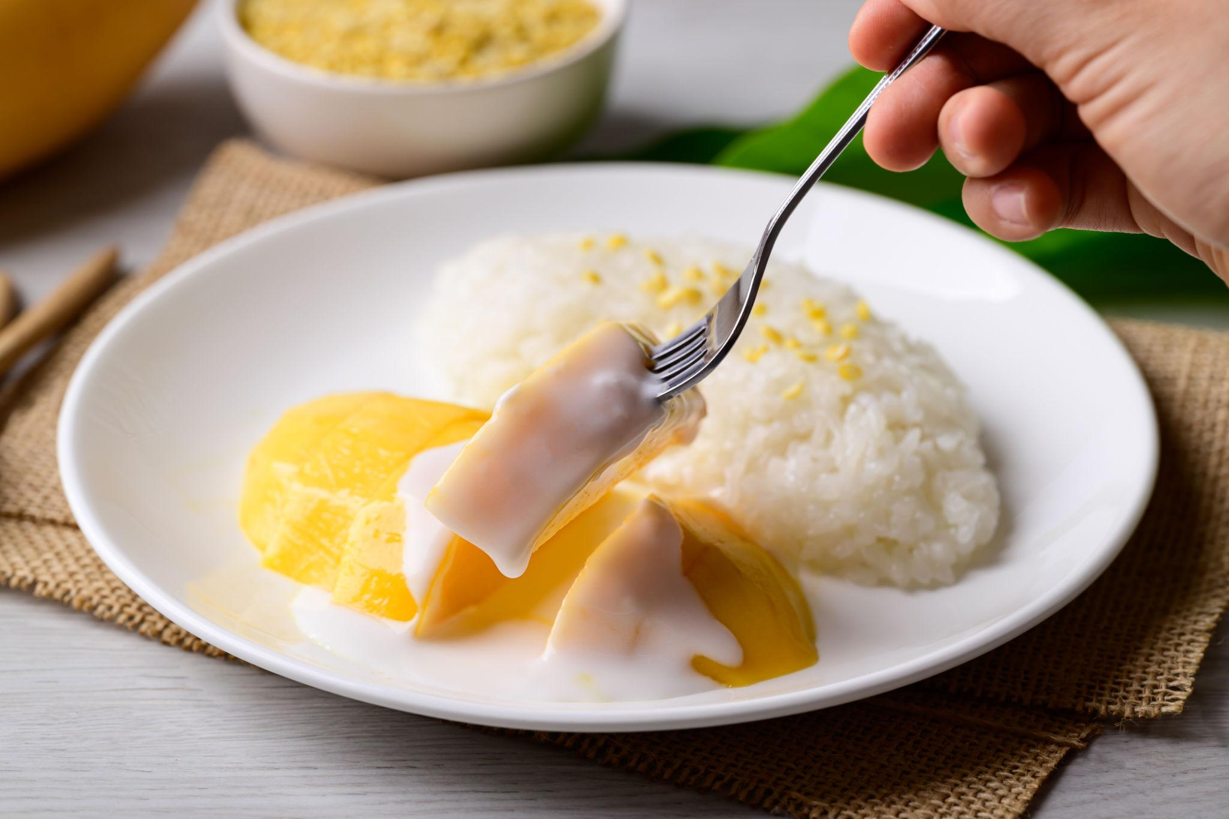
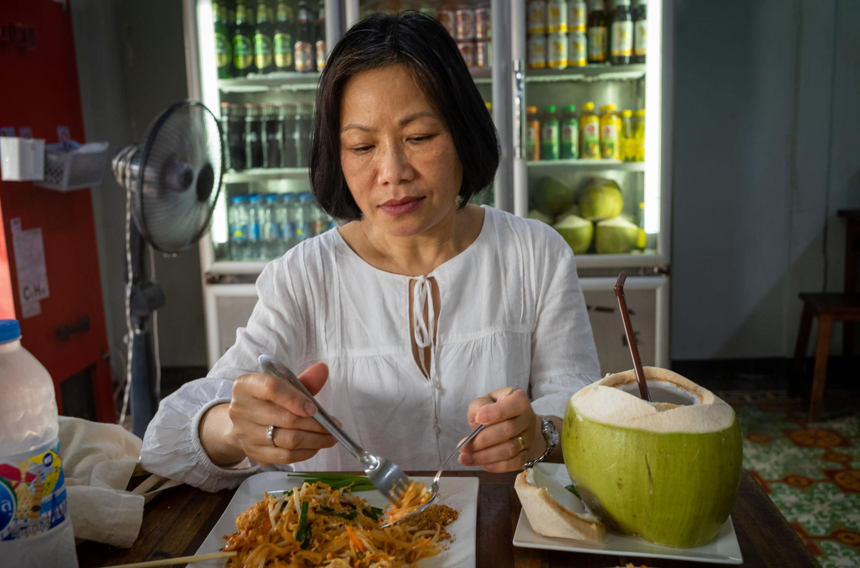

Luxury Experiences in Thailand ✨
- Luxury beachfront villas
- Private island tours
- Yacht cruises in Phuket
- Rooftop dining in Bangkok
- Luxury spa retreats
- Private snorkeling tours


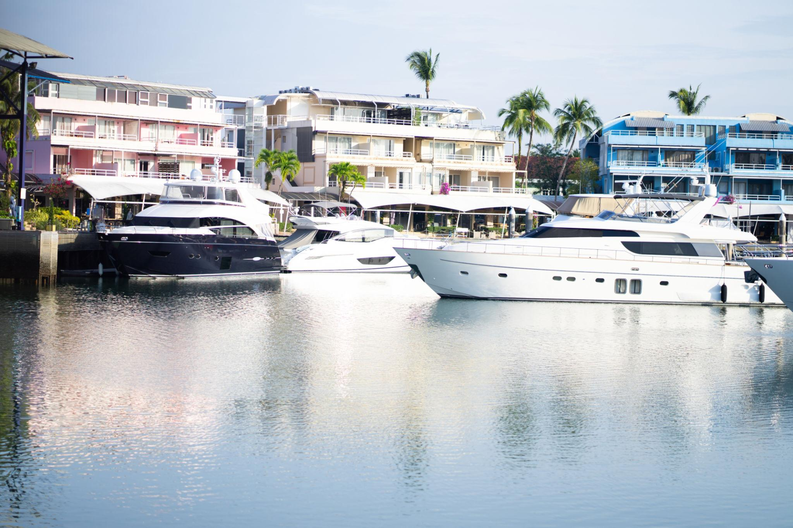
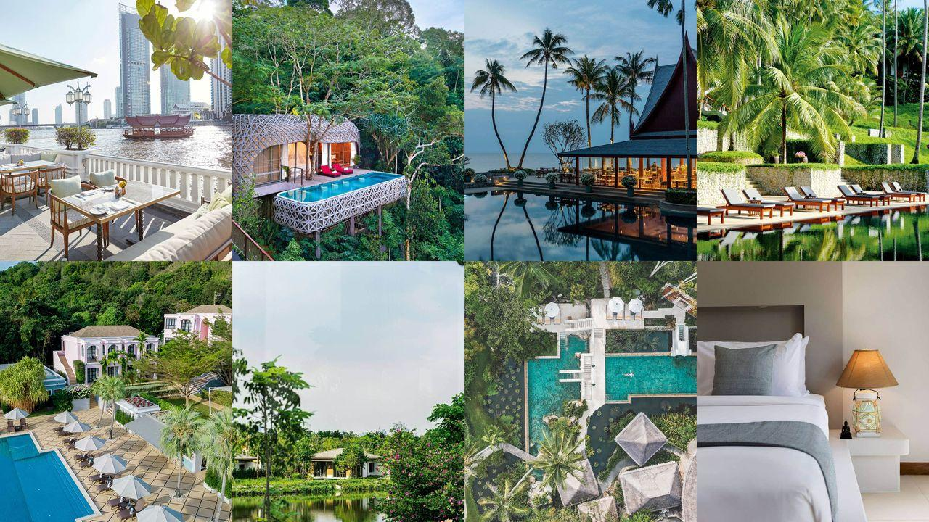

Thailand Travel Tips
- Carry light cotton clothing
- Respect temple dress codes
- Bargain politely at local markets
- Use Grab app for transport
- Stay hydrated in tropical weather
- Book island tours in advance

Why Choose INTRO TRAVELS INDIA for Thailand?
With INTRO TRAVELS INDIA, you get:
- Customized Thailand holiday packages
- Honeymoon & family tours
- Budget & luxury hotel options
- Visa assistance
- Airport transfers
- Guided sightseeing tours
- Indian meal options
- Island tour bookings
- Group departures & private tours
Thailand is a destination where tropical beauty, exciting nightlife, rich culture, luxury resorts, and unforgettable adventures come together to create the perfect holiday experience. ✈️🌴

